Shrinkage correlation: EURUSD and USDCHF
Method 08 / eight-major panel / delta = 0.2 and Ledoit-Wolf / Alpari D1 full available history

Study setup
Logical pair: EURUSD , USDCHF
Broker symbols: EURUSD_i , USDCHF_i
Snapshot: 2026-11-03_majors_alpari_D1
Timeframe: D1
Common eight-major panel window: 1999-01-06 to 2026-11-02 (UTC bar dates)
Panel matched return count n: 7127
Dropped unfinished last bar dated 2026-11-03 UTC after a tick-volume check against the prior complete day.
Fixed shrinkage: delta=0.2, mu=3.9170889e-05 (mean of diag(S))
Ledoit-Wolf estimated delta: 0.0042157642
Panel symbols: EURUSD, GBPUSD, AUDUSD, NZDUSD, USDJPY, USDCHF, USDCAD, EURGBP
Complete matched rows (Excel): EURUSD-USDCHF_Shrinkage_D1.xlsx
Complete matched rows (HTML table): EURUSD-USDCHF_Shrinkage_D1_data.html

Method carried forward
Shrinkage blends the sample covariance matrix S of matched daily log returns of close, ln(close_t / close_t-1), toward a simple target, then converts the shrunk covariance into correlations. Quotes are not inverted. This experiment builds one common calendar across all eight majors, forms S with the unbiased n-1 divisor, then reports two shrinkage specs: fixed delta = 0.2 with mu equal to the average sample variance (mu * I target), and sklearn Ledoit-Wolf with its estimated delta. Pair reports pull rho_ij from those panel matrices. Same-panel Pearson r is a side check only. Shrinkage improves conditioning; it is not a cause, not a lead, and not a trading signal.

Results
pearson_r | rho_02 | rho_LW | rho_02_minus_r | rho_LW_minus_r | delta_LW
-0.747345 | -0.594158 | -0.744091 | 0.153187 | 0.003254 | 0.00421576

Conclusion
Over the common 7127-day eight-major panel for EURUSD and USDCHF (broker quote directions unchanged), fixed-delta shrinkage correlation at delta=0.2 is -0.5942 (negative, moderate linear link in this sample). Ledoit-Wolf rho is -0.7441 with estimated delta=0.004216. Same-panel Pearson r is -0.7473 (rho_02 minus r = 0.1532; rho_LW minus r = 0.0033). This does not establish cause, lead-lag, or a lasting trading rule.

Charts
Daily closes
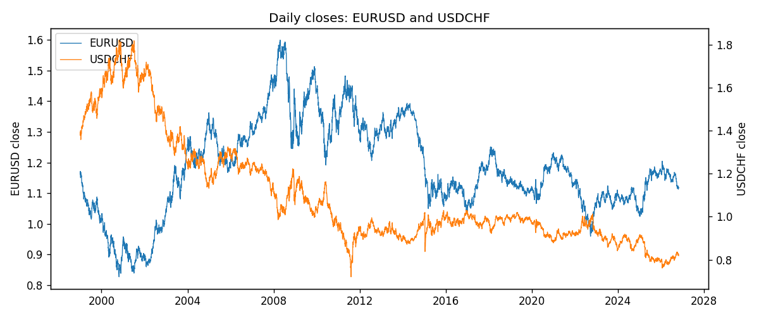
Daily log returns
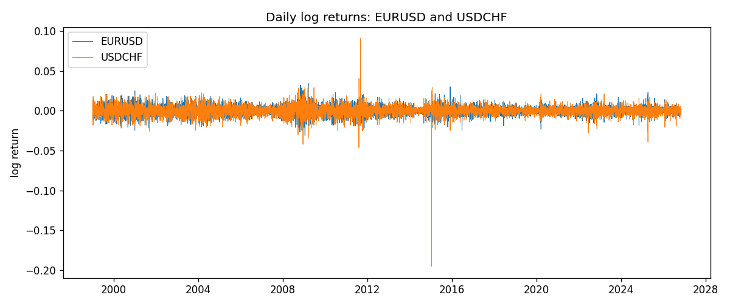
Log-return scatter
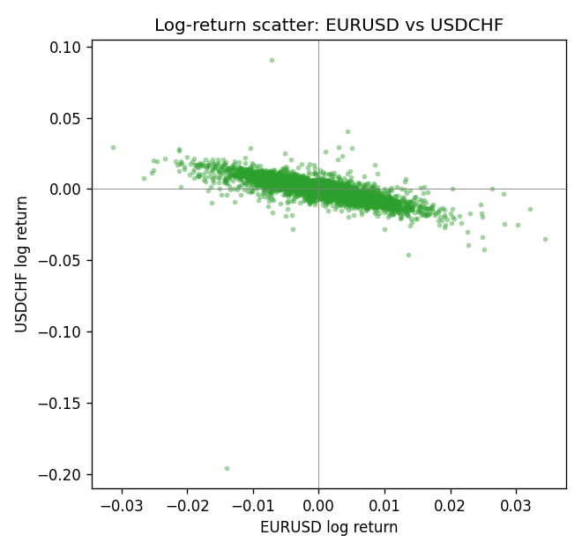

Data report
Every panel row for this pair slice is stored in the sibling Excel workbook named EURUSD-USDCHF_Shrinkage_D1.xlsx. Full-panel covariance and correlation matrices are saved once under outputs/ as CSV files. Embedding all rows as a Word table is impractical at this length; the Word file holds the column list, column summaries, and the first and last 15 matched rows.
Columns: time, EURUSD_open, EURUSD_high, EURUSD_low, EURUSD_close, EURUSD_tick_volume, EURUSD_spread, EURUSD_real_volume, EURUSD_log_return, USDCHF_open, USDCHF_high, USDCHF_low, USDCHF_close, USDCHF_tick_volume, USDCHF_spread, USDCHF_real_volume, USDCHF_log_return
Column summaries (panel rows)
column | count | mean | std | min | 25% | 50% | 75% | max
EURUSD_open | 7127 | 1.1819407 | 0.15065555 | 0.8272 | 1.086455 | 1.16615 | 1.294285 | 1.5995
EURUSD_high | 7127 | 1.1870746 | 0.15125674 | 0.8326 | 1.09055 | 1.17128 | 1.29974 | 1.6038
EURUSD_low | 7127 | 1.1769341 | 0.14996546 | 0.8227 | 1.082375 | 1.16257 | 1.288915 | 1.5865
EURUSD_close | 7127 | 1.1819858 | 0.15061943 | 0.8267 | 1.08652 | 1.16617 | 1.294345 | 1.5997
EURUSD_tick_volume | 7127 | 103994.86 | 174033.72 | 469 | 9542.5 | 53148 | 99923.5 | 1471626
EURUSD_spread | 7127 | 19.176652 | 16.472988 | 0 | 8 | 12 | 20 | 50
EURUSD_real_volume | 7127 | 4.0656436e+10 | 1.6756658e+11 | 0 | 0 | 0 | 0 | 3.6149665e+12
EURUSD_log_return | 7127 | -3.8e-07 | 0.00580028 | -0.03123819 | -0.00324243 | 8.31e-06 | 0.00325629 | 0.03433183
USDCHF_open | 7127 | 1.0950724 | 0.25120393 | 0.72022 | 0.92018 | 0.98921 | 1.23375 | 1.8219
USDCHF_high | 7127 | 1.1003422 | 0.25292835 | 0.73305 | 0.924355 | 0.99265 | 1.2388 | 1.8313
USDCHF_low | 7127 | 1.0899719 | 0.24962782 | 0.08565 | 0.91675 | 0.98562 | 1.22815 | 1.8121
USDCHF_close | 7127 | 1.0950652 | 0.25109829 | 0.72025 | 0.92039 | 0.98915 | 1.23375 | 1.8217
USDCHF_tick_volume | 7127 | 74858.54 | 113805.19 | 350 | 12933.5 | 40528 | 70784 | 858589
USDCHF_spread | 7127 | 25.804827 | 24.609722 | 0 | 5 | 16 | 50 | 100
USDCHF_real_volume | 7127 | 2.3477824e+10 | 8.9470976e+10 | 0 | 0 | 0 | 0 | 1.9331921e+12
USDCHF_log_return | 7127 | -7.023e-05 | 0.006591 | -0.19545699 | -0.00334576 | 8.055e-05 | 0.00331687 | 0.09051364
First 15 panel rows (selected columns)
time | EURUSD_close | USDCHF_close | EURUSD_log_return | USDCHF_log_return
1999-01-06 | 1.1623 | 1.3912 | -0.011547966 | 0.013605652
1999-01-07 | 1.1712 | 1.3782 | 0.0076280636 | -0.0093883841
1999-01-08 | 1.1585 | 1.3935 | -0.010902799 | 0.011040268
1999-01-11 | 1.1503 | 1.4009 | -0.007103287 | 0.0052963193
1999-01-12 | 1.1555 | 1.3872 | 0.0045103728 | -0.0098275602
1999-01-13 | 1.1681 | 1.3621 | 0.010845346 | -0.018259701
1999-01-14 | 1.1681 | 1.3588 | 0 | -0.0024256692
1999-01-15 | 1.1563 | 1.3834 | -0.010153245 | 0.01794228
1999-01-18 | 1.1605 | 1.379 | 0.0036256946 | -0.0031856384
1999-01-19 | 1.1603 | 1.3789 | -0.00017235436 | -7.2518946e-05
1999-01-20 | 1.1566 | 1.3889 | -0.0031939256 | 0.0072259871
1999-01-21 | 1.1601 | 1.3836 | 0.0030215416 | -0.0038232689
1999-01-22 | 1.1587 | 1.3834 | -0.0012075213 | -0.0001445609
1999-01-25 | 1.1552 | 1.3868 | -0.0030251979 | 0.0024546976
1999-01-26 | 1.1562 | 1.3897 | 0.00086527651 | 0.0020889617
Last 15 panel rows (selected columns)
time | EURUSD_close | USDCHF_close | EURUSD_log_return | USDCHF_log_return
2026-10-13 | 1.11965 | 0.83244 | 0.0037402957 | -0.0024955621
2026-10-14 | 1.11545 | 0.83489 | -0.0037582255 | 0.0029388325
2026-10-15 | 1.12172 | 0.82676 | 0.0056053107 | -0.0097855323
2026-10-16 | 1.12371 | 0.82377 | 0.0017724895 | -0.0036230826
2026-10-19 | 1.12086 | 0.82677 | -0.0025394633 | 0.0036351779
2026-10-20 | 1.12354 | 0.8246 | 0.0023881672 | -0.0026281224
2026-10-21 | 1.12318 | 0.82427 | -0.00032046717 | -0.00040027413
2026-10-22 | 1.12139 | 0.82032 | -0.0015949606 | -0.0048036381
2026-10-23 | 1.11989 | 0.82497 | -0.001338521 | 0.005652514
2026-10-26 | 1.11735 | 0.82649 | -0.0022706559 | 0.0018407959
2026-10-27 | 1.11272 | 0.82865 | -0.004152342 | 0.0026100526
2026-10-28 | 1.1152 | 0.82781 | 0.0022262927 | -0.0010142111
2026-10-29 | 1.11772 | 0.82379 | 0.0022571351 | -0.0048680164
2026-10-30 | 1.11644 | 0.82438 | -0.0011458446 | 0.00071594559
2026-11-02 | 1.11881 | 0.81851 | 0.002120569 | -0.0071459744

